NAME: Talari Vyshnavi

MAIL ID: [talari.vyshu@gmail.com](mailto:talari.vyshu@gmail.com)

**TOPICS ASSIGNMENT**:

Application packaging process:

Application packing is a software that runs program. End-To-End application packaging process they are five stages. They are;

* + - * IDENTIFY AND COLLECT
      * REVIEW AND ASSESS
      * PACKAGE
      * TEST
      * DEPLOY

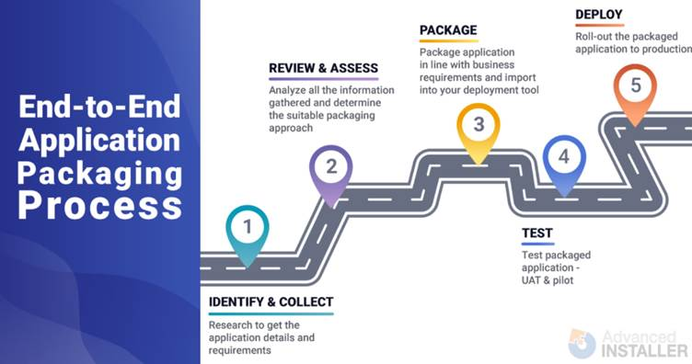

Application package that needs to be installed by end production device.

**Needs of application packaging;**

* Standardization
* Easy deployment
* Error reduction
* Security and Control
* Supports for virtualization
* Easy updates and uninstallation
* Better Troubleshooting

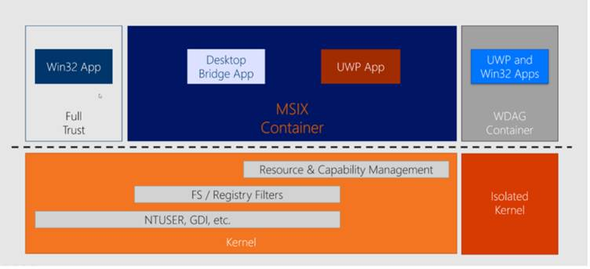

This a new MSIX packing format.

**END-TO-END PACKING PROCESS**

* Application Discovery
* Application Packaging
* UAT [ User Acceptance Testing ]

* APPLICATION DISCOVERY :
* Validating the application source file.
* And ensuring that the application is fully functional within the organization environment and that it works as excepted.

* APPLICATION PACKAGING :

Application packaging covers the actual package creation based on the requirement and details gathered I the discovery stage.

* UAT :

User Acceptance Testing is the step of the application before the packaged application in deployed to production and it consists of validating the package created and making sure that the packaged application is fully functional and work as excepted. Basically, it must behave the same as the vendor source file tested earlier in the discovery stage.

* APPLICATION DEPLOYMENT :

Application deployment is the process of installing a package created using a software management tool such as configuration manager ( formally known as SCCM )

* **WINDOWS 10 VS WINDOWS 11**

Windows 11 :

Windows 11 was interface with redesigned start menu and taskbar and rounded corer and modern look. Enhanced security like TPM 2.0 and windows hello and also offers a biometric authentication for secure access to devices, apps and networks.

Its performance optimizations that result in faster logins, faster web design and faster wake-up times. It introduces the multi-tasking like snap groups and snap layouts, making it easier to organize and manage multiple application. It is an integrated AI Assistant providing windows copilot, AI=powered assistant, providing assistance with various tasks and improving productivity.

Windows 10 :

Windows 10 is familiar interface . Wide compatibility with a vast arry of applications and hardware. Stability and Reliability, making it good choice for users and Cost-Effective.

* **APP PACK :**

App compatibility – most applications and games should work on both windows 10 and 11. So a best decision to check app compatibility.

Performance – windows11 offers better performance overall , but the actual performance depend on the app and hardware.

Features – windows11 new features like snap group and snap layout, windows copilot, enhanced productivity and multi-tasking.

* **DIFFERENCE BETWEEN USE CONTEXT, SYSTEM CONTEXT AND ADMIN CONTEXT.**

* **USE CONTEXT :**

Definition : runs under the currently logged-in users credientials and within their user profile.

Access : can access file and settings specific to the user profile but typically doesn’t have fill system-wide access.

Beat for : user specific applications, customizations and tasks tht don’t require system side changes.

* **SYSTEM CONTEXT** :

Definition : runs with elevated privilegs, often as the system user with full system-wide access.

Access : has access to all files and system resources, including those outside the user’s profile.

Best for : system-wide installations, critical system policies, 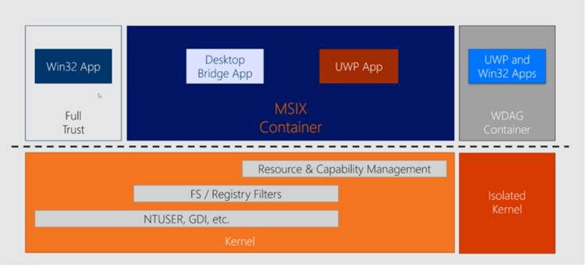Definition : Although not a distinct context like user or system many MSI installations that requires system-wide changes might require admin privileges.

Access : these installations require the user to have admin privileges to run the MSI and perform the necessary system changes.

Best for : installations that modify system files services or other resources that require elevated permissions.

A small summary for use , system and admin context;

User context- limited access to the users profile

System context- full system wide access

Admin context- requires admin privileges for system-wide access.

NAME: Talari Vyshnavi

MAIL ID: [talari.vyshu@gmail.com](mailto:talari.vyshu@gmail.com)

**TOPICS ASSIGNMENT**:

Application packaging process:

Application packing is a software that runs program. End-To-End application packaging process they are five stages. They are;

* + - * IDENTIFY AND COLLECT
      * REVIEW AND ASSESS
      * PACKAGE
      * TEST
      * DEPLOY



Application package that needs to be installed by end production device.

**Needs of application packaging;**

* Standardization
* Easy deployment
* Error reduction
* Security and Control
* Supports for virtualization
* Easy updates and uninstallation
* Better Troubleshooting



This a new MSIX packing format.

**END-TO-END PACKING PROCESS**

* Application Discovery
* Application Packaging
* UAT [ User Acceptance Testing ]

* APPLICATION DISCOVERY :
* Validating the application source file.
* And ensuring that the application is fully functional within the organization environment and that it works as excepted.

* APPLICATION PACKAGING :

Application packaging covers the actual package creation based on the requirement and details gathered I the discovery stage.

* UAT :

User Acceptance Testing is the step of the application before the packaged application in deployed to production and it consists of validating the package created and making sure that the packaged application is fully functional and work as excepted. Basically, it must behave the same as the vendor source file tested earlier in the discovery stage.

* APPLICATION DEPLOYMENT :

Application deployment is the process of installing a package created using a software management tool such as configuration manager ( formally known as SCCM )

* **WINDOWS 10 VS WINDOWS 11**

Windows 11 :

Windows 11 was interface with redesigned start menu and taskbar and rounded corer and modern look. Enhanced security like TPM 2.0 and windows hello and also offers a biometric authentication for secure access to devices, apps and networks.

Its performance optimizations that result in faster logins, faster web design and faster wake-up times. It introduces the multi-tasking like snap groups and snap layouts, making it easier to organize and manage multiple application. It is an integrated AI Assistant providing windows copilot, AI=powered assistant, providing assistance with various tasks and improving productivity.

Windows 10 :

Windows 10 is familiar interface . Wide compatibility with a vast arry of applications and hardware. Stability and Reliability, making it good choice for users and Cost-Effective.

* **APP PACK :**

App compatibility – most applications and games should work on both windows 10 and 11. So a best decision to check app compatibility.

Performance – windows11 offers better performance overall , but the actual performance depend on the app and hardware.

Features – windows11 new features like snap group and snap layout, windows copilot, enhanced productivity and multi-tasking.

* **DIFFERENCE BETWEEN USE CONTEXT, SYSTEM CONTEXT AND ADMIN CONTEXT.**

* **USE CONTEXT :**

Definition : runs under the currently logged-in users credientials and within their user profile.

Access : can access file and settings specific to the user profile but typically doesn’t have fill system-wide access.

Beat for : user specific applications, customizations and tasks tht don’t require system side changes.

* **SYSTEM CONTEXT** :

Definition : runs with elevated privilegs, often as the system user with full system-wide access.

Access : has access to all files and system resources, including those outside the user’s profile.

Best for : system-wide installations, critical system policies, Definition : Although not a distinct context like user or system many MSI installations that requires system-wide changes might require admin privileges.

Access : these installations require the user to have admin privileges to run the MSI and perform the necessary system changes.

Best for : installations that modify system files services or other resources that require elevated permissions.

A small summary for use , system and admin context;

User context- limited access to the users profile

System context- full system wide access

Admin context- requires admin privileges for system-wide access.